Roy and Profile Picture
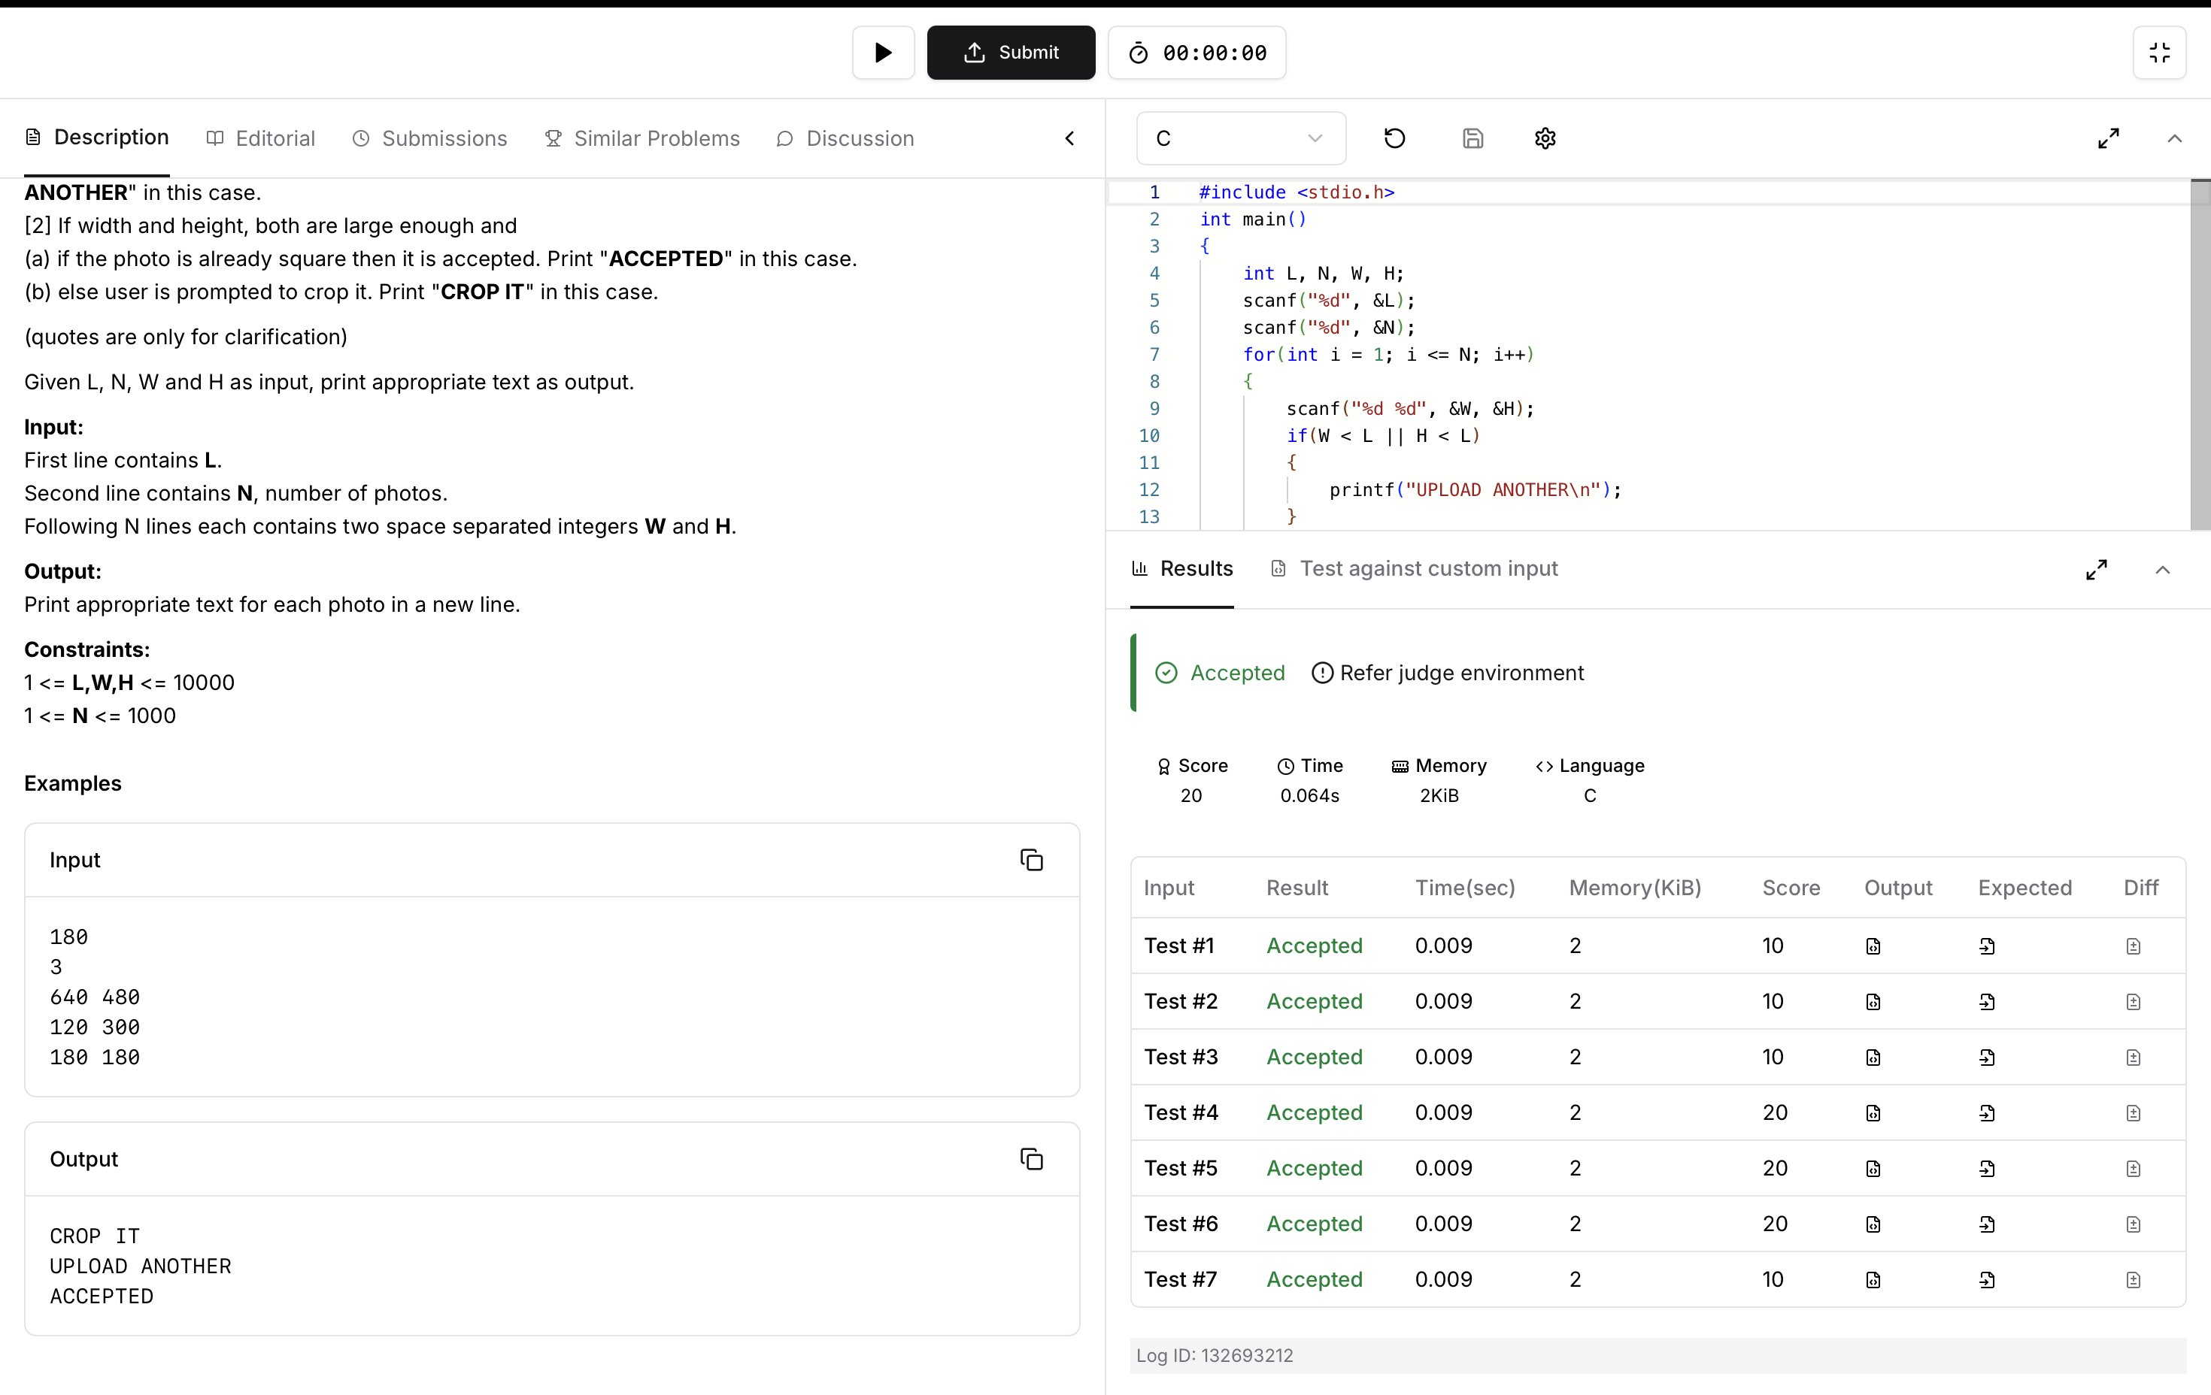
Code:
#include <stdio.h>
int main()
{
int L, N, W, H;
scanf("%d", &L);
scanf("%d", &N);
for(int i = 1; i <= N; i++)
{
scanf("%d %d", &W, &H);
if(W < L || H < L)
{
printf("UPLOAD ANOTHER\n");
}
else if(W == H)
{
printf("ACCEPTED\n");
}
else
{
printf("CROP IT\n");
}
}
return 0;
}

